Communicating the Status of Testing
# Source: AI Source: Provided by: [Data Path: Persons Table -> ID Column: 1, Name_En Column: Motasem Essam] -> From: [ChatGPT] on [8/21/2025]
In software testing, communicating the status of testing means keeping stakeholders (managers, developers, product owners, clients, etc.) informed about:
- How testing is progressing
- What has been completed
- What issues/defects exist
- Whether the system is ready for release

🔹 Definition
# Source: AI Source: Provided by: [Data Path: Persons Table -> ID Column: 1, Name_En Column: Motasem Essam] -> From: [ChatGPT] on [8/21/2025]
It is the process of reporting test progress, quality levels, risks, and outcomes to stakeholders throughout the test life cycle.
This is usually done through meetings, dashboards, and reports.

🔑 Objectives
# Source: AI Source: Provided by: [Data Path: Persons Table -> ID Column: 1, Name_En Column: Motasem Essam] -> From: [ChatGPT] on [8/21/2025]
- Provide visibility into test progress (planned vs actual).
- Share information about defects (open, closed, severity, trends).
- Highlight risks and blockers.
- Support decision-making (e.g., “Are we ready to release?”).
- Ensure transparency and alignment across the team.

📂 What is Communicated?
# Source: AI Source: Provided by: [Data Path: Persons Table -> ID Column: 1, Name_En Column: Motasem Essam] -> From: [ChatGPT] on [8/21/2025]
- Test Progress – % of planned tests executed, passed, failed.
- Defect Status – number, severity, priority, trends.
- Test Coverage – requirements, code, or risk coverage.
- Quality Indicators – defect density, open defects, failure rate.
- Risks & Issues – anything that may delay or impact release.
- Next Steps – what testers will focus on in the upcoming cycle.

📝 Ways to Communicate
# Source: AI Source: Provided by: [Data Path: Persons Table -> ID Column: 1, Name_En Column: Motasem Essam] -> From: [ChatGPT] on [8/21/2025]
- Daily/Status Reports – short updates on testing progress.
- Test Summary Reports (TSR) – final testing outcome after test completion.
- Dashboards & Metrics – real-time visual reports (charts, defect trends).
- Meetings/Stand-ups – verbal updates in Agile teams (daily scrums).
- Defect Reports – logged in defect tracking tools (e.g., JIRA).

Daily / Status Reports
# Source: AI Source: Provided by: [Data Path: Persons Table -> ID Column: 1, Name_En Column: Motasem Essam] -> From: [ChatGPT] on [8/21/2025]
- Meaning:
  - Written or electronic update communicating current progress, issues, and results of testing activities.
- Goal:
  - Keep project managers, test managers, and team members informed.
  - Highlight risks, blockers, defects, and deviations.
  - Support release readiness decisions.
- Scope:
  - Covers individual tester updates or overall project testing progress.
  - Includes test execution results, defect status, and planned activities.
- When Used:
  - Daily in Agile or iterative projects.
  - Weekly or at milestones in traditional projects.
- Typical Contents:
  - Number of test cases planned, executed, passed, failed, blocked.
  - Defects logged, fixed, or pending.
  - Risks or issues affecting testing.
  - Planned testing activities for the next period.
- Example:
  - 50 test cases executed → 45 passed, 5 failed
  - 3 new defects logged
  - Regression testing for login module pending
  - No blockers reported
- Shortcut to Remember:
  - Daily/Status Reports = Keep everyone informed about testing progress, defects, and risks

Test Summary Reports (TSR)
# Source: AI Source: Provided by: [Data Path: Persons Table -> ID Column: 1, Name_En Column: Motasem Essam] -> From: [ChatGPT] on [8/21/2025]
- Meaning:
  - A formal document that provides a comprehensive summary of testing activities, results, and conclusions at the end of a test phase or project.
- Goal:
  - Inform stakeholders about the overall quality of the system under test.
  - Support release decisions and highlight risks, defects, and coverage.
- Scope:
  - Covers the entire testing phase or project, including functional, non-functional, regression, and system testing.
  - Summarizes test coverage, execution, defects, metrics, and deviations from the test plan.
- When Used:
  - At the end of a test phase (e.g., system testing, UAT).
  - Before project milestones or release decisions.
- Typical Contents:
  - Test objectives and scope
  - Summary of test cases executed, passed, failed, or blocked
  - Defect summary (open, closed, severity, priority)
  - Test coverage achieved
  - Risks, issues, and recommendations
  - Overall conclusion on system quality and release readiness
- Example:
  - System testing executed: 200 test cases → 180 passed, 15 failed, 5 blocked
  - 12 critical defects unresolved, 5 major defects pending
  - Test coverage achieved: 95% of requirements
  - Recommendation: Release with critical defects fixed
- Shortcut to Remember:
  - TSR = End-of-phase report summarizing testing results, coverage, defects, and release readiness

Dashboards & Metrics
# Source: AI Source: Provided by: [Data Path: Persons Table -> ID Column: 1, Name_En Column: Motasem Essam] -> From: [ChatGPT] on [8/21/2025]
- Meaning:
  - Visual representation of testing progress, results, and key performance indicators (KPIs) using graphs, charts, and tables.
- Goal:
  - Provide real-time, easy-to-understand insights to stakeholders.
  - Highlight trends, risks, defects, and coverage at a glance.
  - Support data-driven decisions about testing and release readiness.
- Scope:
  - Can cover test execution progress, defect status, requirement coverage, and team performance.
  - Often used for ongoing projects to monitor progress continuously.
- When Used:
  - Throughout the testing phase, updated daily or in real-time.
  - During status meetings or reviews to show overall project health.
- Typical Contents / Metrics:
  - Test execution: Planned vs executed, passed, failed, blocked
  - Defect metrics: Open, closed, severity distribution, defect density
  - Coverage metrics: Requirements coverage, code coverage, risk coverage
  - Trend charts: Defect trends over time, test execution trends
  - Team performance metrics: Test case productivity, defect detection rate
- Example:
  - A dashboard shows:
    - 500 test cases planned → 400 executed → 350 passed, 50 failed
    - 30 open defects → 5 critical, 10 major, 15 minor
    - Requirement coverage: 92%
    - Defect trend chart shows decreasing open defects over the past week
- Shortcut to Remember:
  - Dashboards & Metrics = Real-time visual snapshot of testing progress, coverage, and defects

Meetings / Stand-ups
# Source: AI Source: Provided by: [Data Path: Persons Table -> ID Column: 1, Name_En Column: Motasem Essam] -> From: [ChatGPT] on [8/21/2025]
- Meaning:
  - Verbal communication sessions where the testing team shares updates, progress, issues, and plans with stakeholders.
  - Commonly includes daily stand-ups in Agile or periodic review meetings in traditional projects.
- Goal:
  - Provide real-time, interactive updates.
  - Highlight blockers, risks, and dependencies.
  - Facilitate quick decision-making and collaboration among team members and stakeholders.
- Scope:
  - Can be daily (stand-ups), weekly, or at milestones.
  - Covers test execution status, defects, risks, and next steps.
- When Used:
  - Daily in Agile projects (typically 15-minute stand-ups).
  - Regular meetings in traditional projects or before key milestones.
- Typical Contents:
  - What was done yesterday
  - What will be done today
  - Blockers or issues affecting progress
  - Defect updates (critical/major)
  - Test coverage or execution summary
- Example:
  - Daily stand-up:
    - Yesterday: 50 test cases executed, 45 passed
    - Today: Execute remaining login module tests
    - Blocker: Environment downtime preventing database tests
- Shortcut to Remember:
  - Meetings/Stand-ups = Quick verbal updates on testing progress, issues, and plans

Defect Reports
# Source: AI Source: Provided by: [Data Path: Persons Table -> ID Column: 1, Name_En Column: Motasem Essam] -> From: [ChatGPT] on [8/21/2025]
- Meaning:
  - A formal or semi-formal document that records details of defects found during testing and communicates them to stakeholders such as developers, test managers, and project managers.
- Goal:
  - Track, monitor, and manage defects throughout the testing lifecycle.
  - Ensure defects are addressed, prioritized, and resolved in a timely manner.
  - Provide a clear audit trail of issues for decision-making and quality assessment.
- Scope:
  - Covers all defects discovered during testing, including severity, priority, status, and impact.
  - Can be used for unit, integration, system, and acceptance testing defects.
- When Used:
  - Continuously during testing, as soon as defects are identified.
  - Used for review meetings, dashboards, and test status reporting.
- Typical Contents:
  - Defect ID / Reference number
  - Defect description and steps to reproduce
  - Severity and priority
  - Status (open, in progress, resolved, closed)
  - Assigned to / responsible person
  - Date reported / date resolved
  - Impact on functionality or release
- Example:
  - Defect ID: D-101
  - Description: Login fails when using special characters in password
  - Severity: Critical, Priority: High
  - Status: Open, Assigned to developer
  - Reported: 20-Aug-2025, Expected fix: 22-Aug-2025
- Shortcut to Remember:
  - Defect Reports = Track and communicate all defects to manage resolution and quality

Summary Table
# Source: AI Source: Provided by: [Data Path: Persons Table -> ID Column: 1, Name_En Column: Motasem Essam] -> From: [ChatGPT] on [8/21/2025]
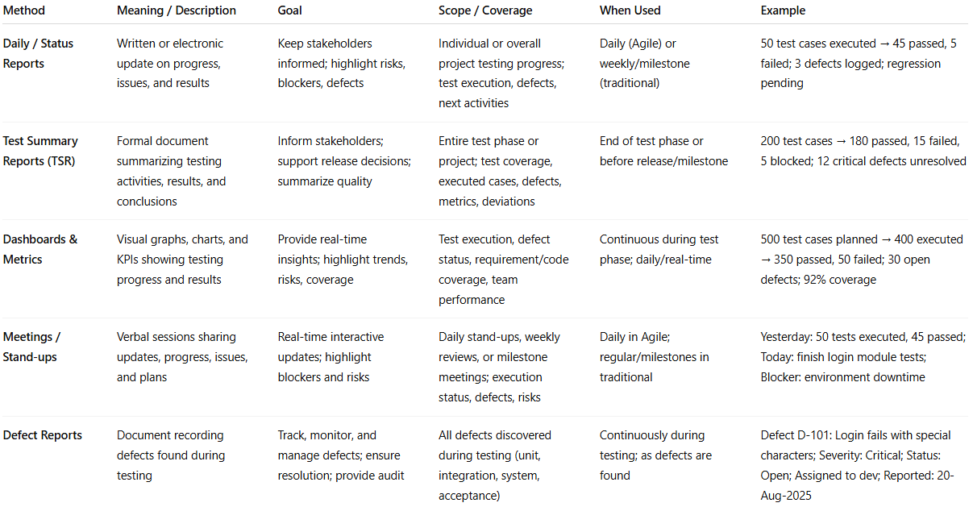

Method | Meaning / Description | Goal | Scope / Coverage | When Used | Example
Daily / Status Reports | Written or electronic update on progress, issues, and results | Keep stakeholders informed; highlight risks, blockers, defects | Individual or overall project testing progress; test execution, defects, next activities | Daily (Agile) or weekly/milestone (traditional) | 50 test cases executed → 45 passed, 5 failed; 3 defects logged; regression pending
Test Summary Reports (TSR) | Formal document summarizing testing activities, results, and conclusions | Inform stakeholders; support release decisions; summarize quality | Entire test phase or project; test coverage, executed cases, defects, metrics, deviations | End of test phase or before release/milestone | 200 test cases → 180 passed, 15 failed, 5 blocked; 12 critical defects unresolved
Dashboards & Metrics | Visual graphs, charts, and KPIs showing testing progress and results | Provide real-time insights; highlight trends, risks, coverage | Test execution, defect status, requirement/code coverage, team performance | Continuous during test phase; daily/real-time | 500 test cases planned → 400 executed → 350 passed, 50 failed; 30 open defects; 92% coverage
Meetings / Stand-ups | Verbal sessions sharing updates, progress, issues, and plans | Real-time interactive updates; highlight blockers and risks | Daily stand-ups, weekly reviews, or milestone meetings; execution status, defects, risks | Daily in Agile; regular/milestones in traditional | Yesterday: 50 tests executed, 45 passed; Today: finish login module tests; Blocker: environment downtime
Defect Reports | Document recording defects found during testing | Track, monitor, and manage defects; ensure resolution; provide audit | All defects discovered during testing (unit, integration, system, acceptance) | Continuously during testing; as defects are found | Defect D-101: Login fails with special characters; Severity: Critical; Status: Open; Assigned to dev; Reported: 20-Aug-2025

📊 Example – Daily Status Report
# Source: AI Source: Provided by: [Data Path: Persons Table -> ID Column: 1, Name_En Column: Motasem Essam] -> From: [ChatGPT] on [8/21/2025]
- Planned test cases: 200
- Executed test cases: 150
- Passed: 120, Failed: 20, Blocked: 10
- Defects: 15 open (5 high, 10 medium)
- Risks: Performance testing delayed due to environment issues
- Next steps: Complete remaining 50 cases + retesting fixed bugs

🎯 Audience
# Source: AI Source: Provided by: [Data Path: Persons Table -> ID Column: 1, Name_En Column: Motasem Essam] -> From: [ChatGPT] on [8/21/2025]
- Project Manager → progress, risks, schedule impact
- Developers → defects, retesting needs
- Product Owners/Clients → product readiness, quality status
- QA Team → coverage, blocked areas

✅ In short
# Source: AI Source: Provided by: [Data Path: Persons Table -> ID Column: 1, Name_En Column: Motasem Essam] -> From: [ChatGPT] on [8/21/2025]
Communicating the status of testing = giving clear, timely, and accurate updates on test progress, defects, coverage, risks, and readiness so stakeholders can make informed decisions.

